Step -1 :
Launch EC2
Connect via SSH
Install Node + Git + Nginx
Clone project
Run backend (npm start)
Test → http://EC2-IP:3000

First creat the Security rules for this application ,
Go to the EC2 and the Networking >> Security Rules
Crea a new Rule ,
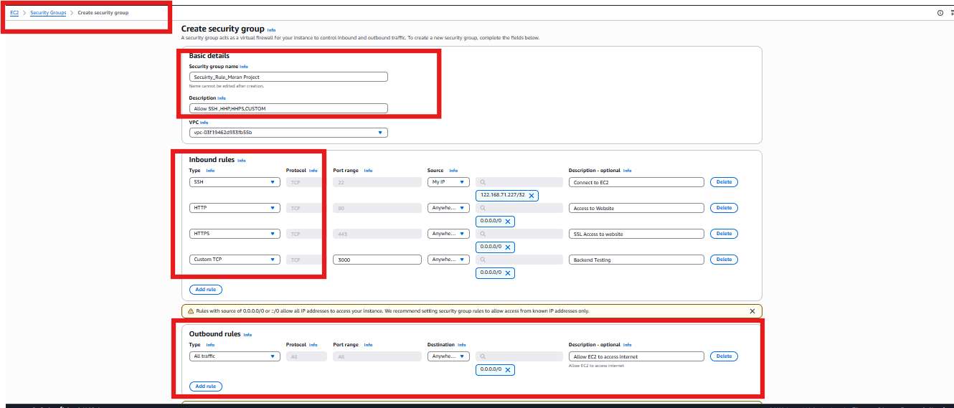
Launch EC2 Instance :
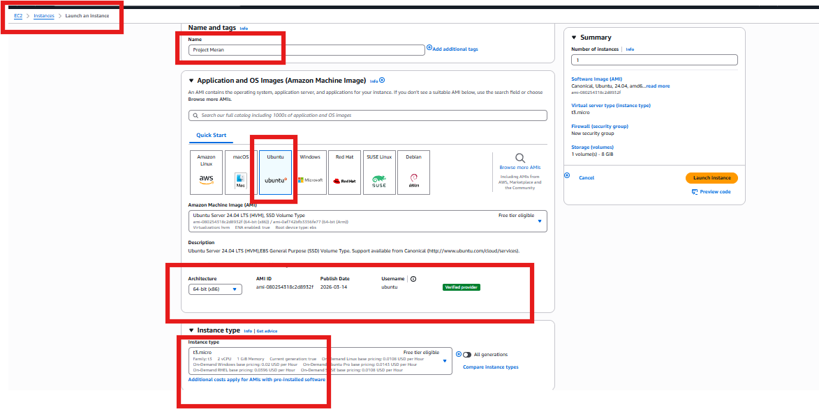

Creta the Keypair .pm for the SSH and HTTP access,
And , we have added the Security policy which we have created earlier
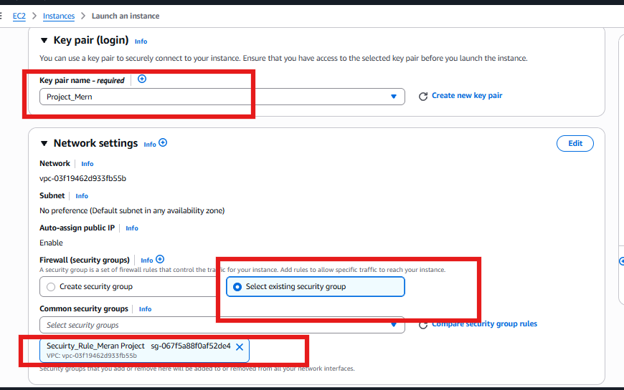
In the Advance feature option, I have used Basch Script to download and install the
System Updates, Node.js , Git,Nginx.
After Launch the instance, Login to instance with EC2
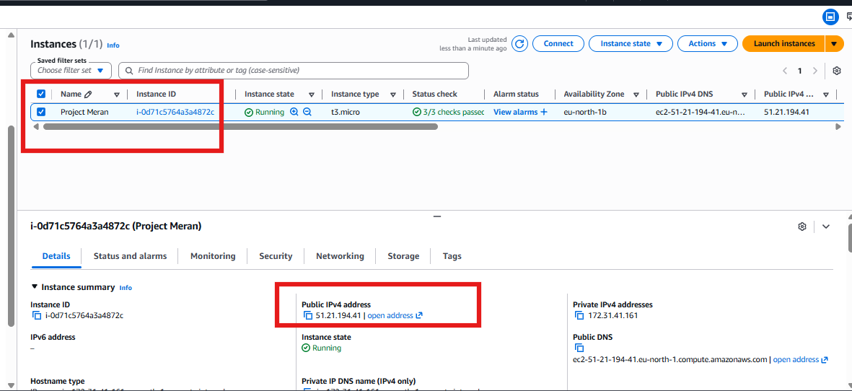
Login to the Putty using the Public IPand the Keypair
check the installed services version details
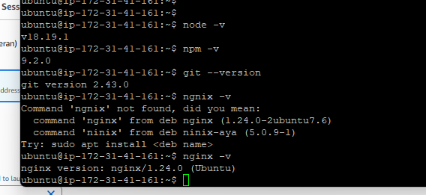

Next step Setup the Mongo DB,
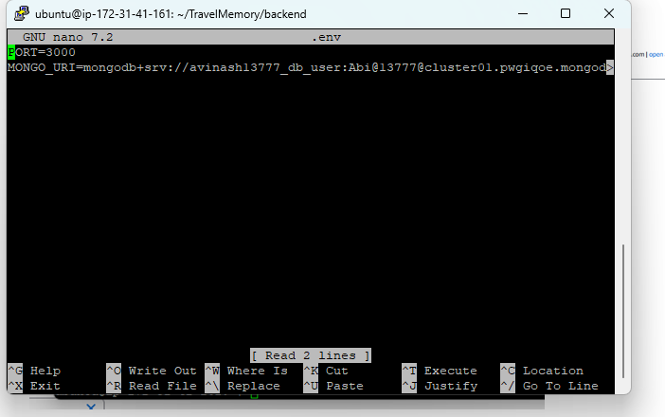

Run the node.js for backedn
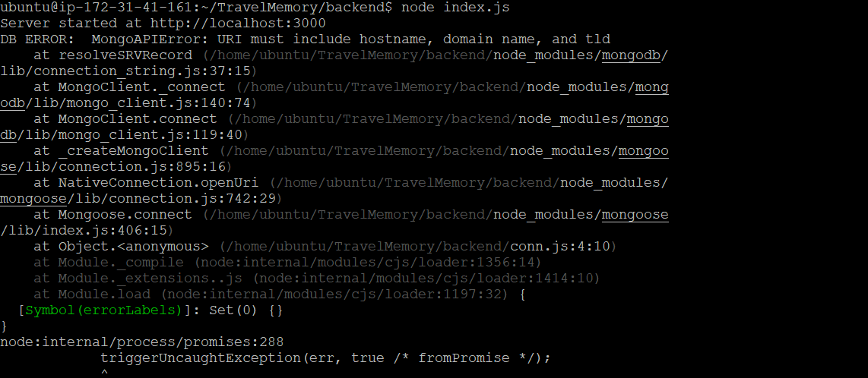
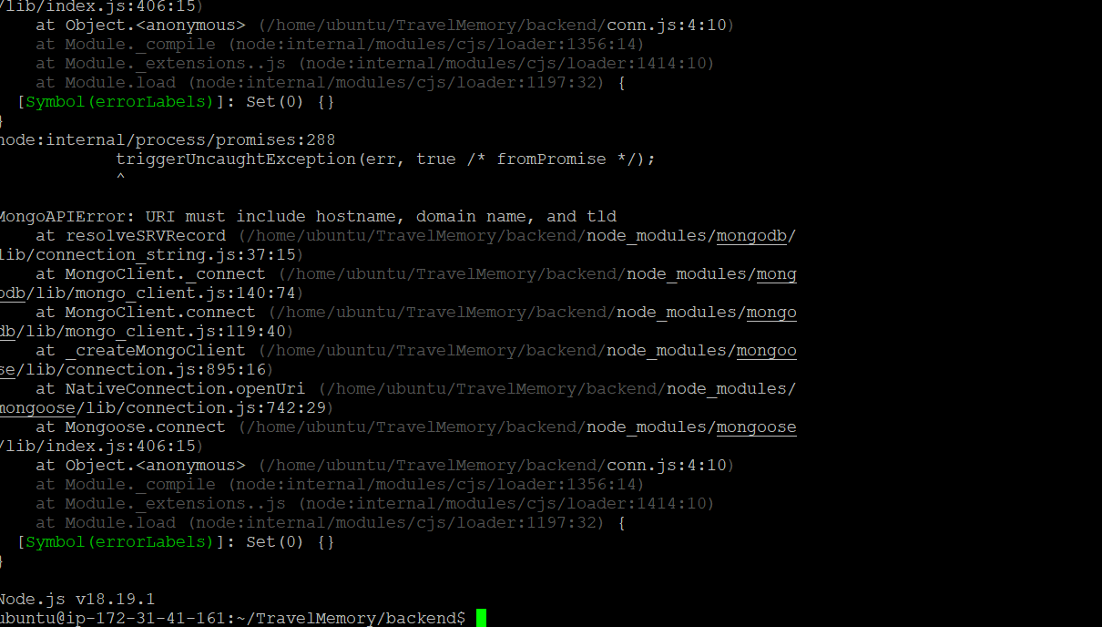
We have connected the MongoDB to the Server, using the DB cluster Details connecting string from mongo DB
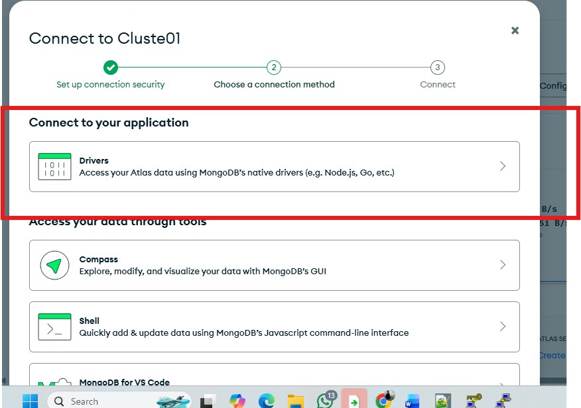
Select the Node.js version latest one
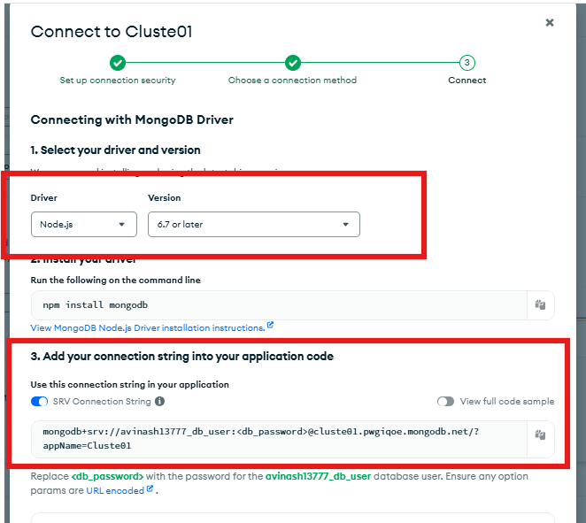
Run the “nano.env”
And verify it
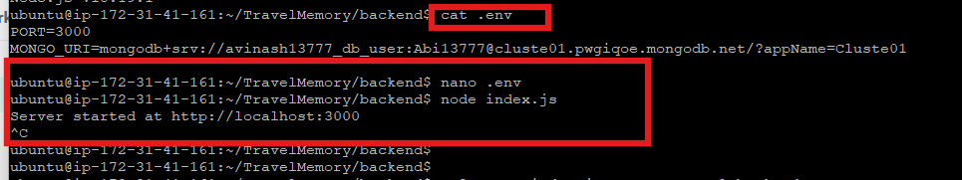
After verfy , We need to creat the Job need to run in backend ,
Install the pm2 and verify it
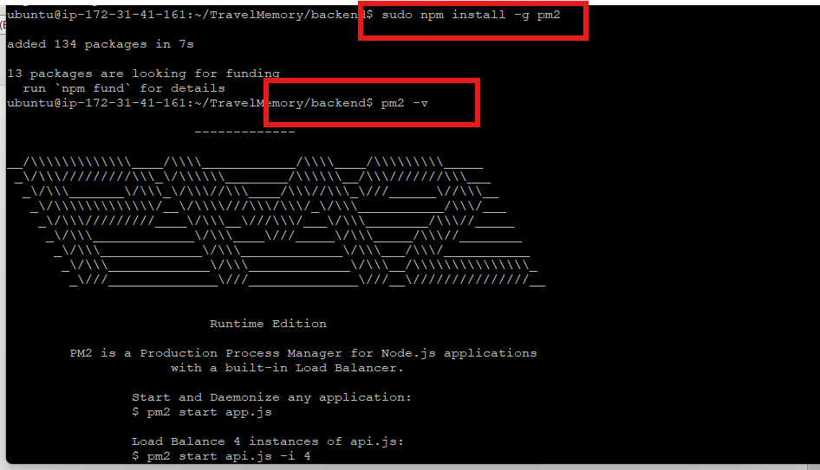
Then start the pm2 in backedn
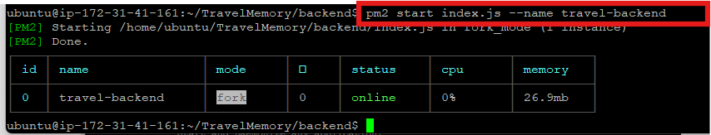
Created the Ngnix new config file instead of default and enabeled it and removed the default config file
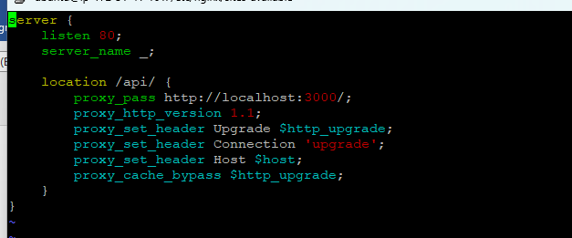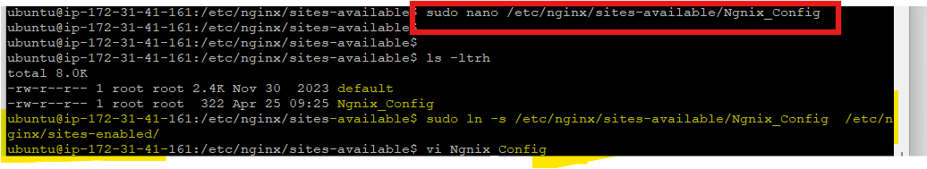
After remove the file, We run the Test connect for Ngnix , Once it came ok <
We can do Restart the Ngnix services
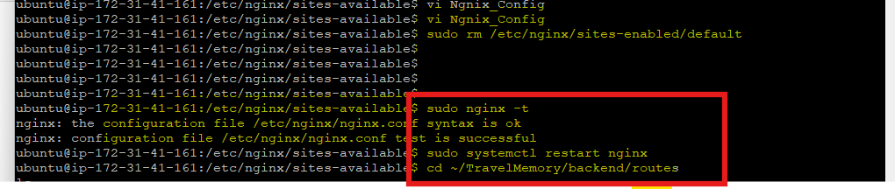
Open the Browser and check with the URL:http: EC2-IP/api/hello
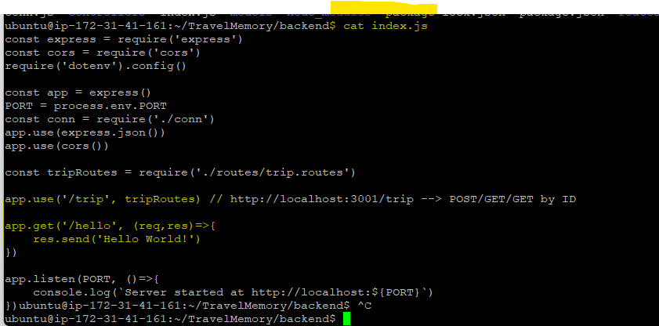
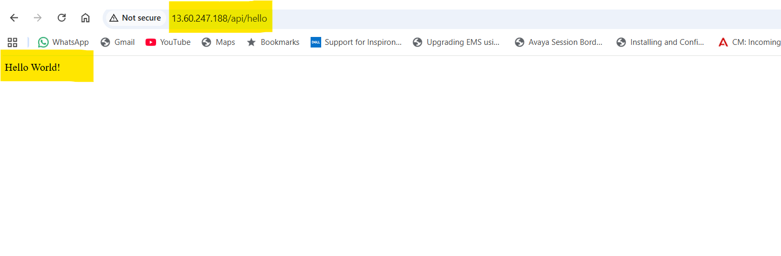
Now We need to creat the Frount end,
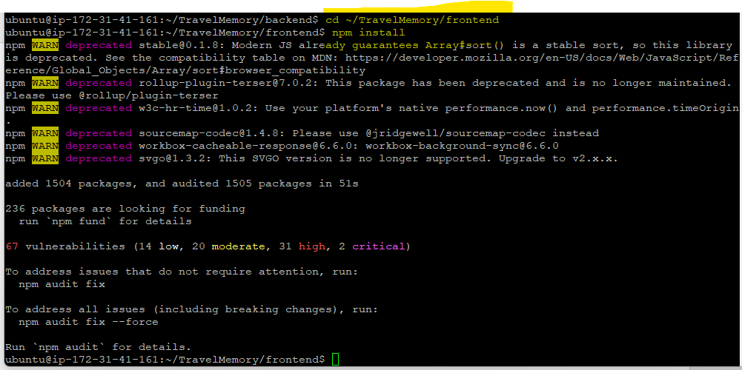

After install npm, We add the public static IP in the script
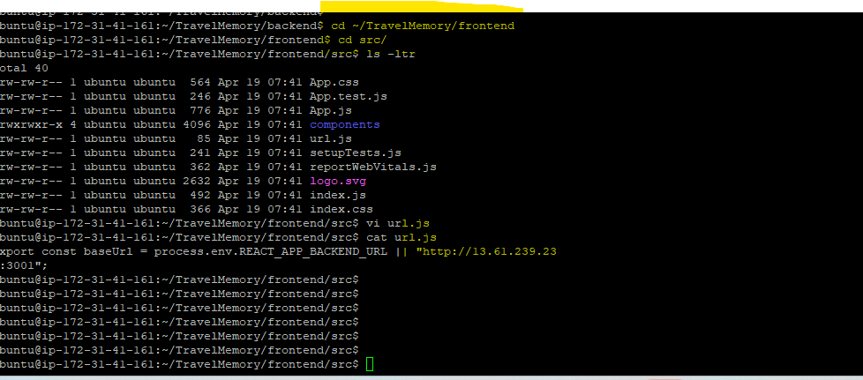
Run the npm buildl for frount end
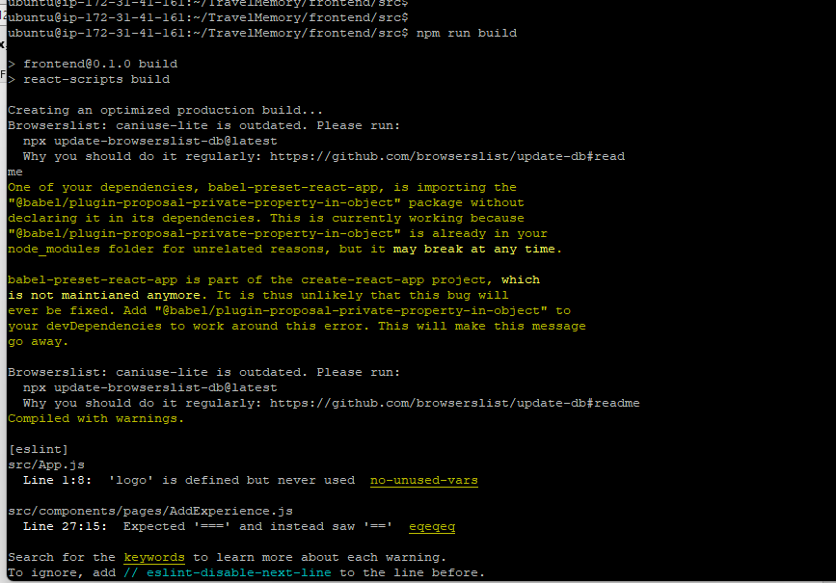

Remove the sudo rm -rf /var/www/html/*
And copy the - $ sudo cp -r * /var/www/html/ in Build folder whichis in frountend path
Then Restart the ngnix services , and Browse the webpage ,
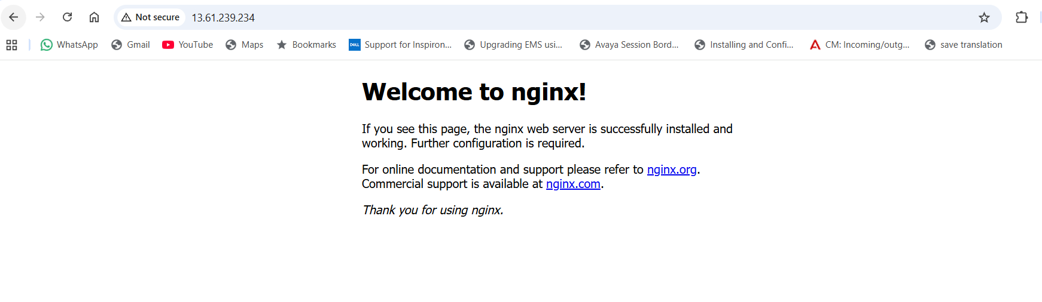

Load Balancer and Scaling

We need to creat a AMI for the current instance
Amazon Machine image , It contains all the instance apps and services , Then We no need to add again for other instances in the load banacer

Go to the EC2 Action s Image and Templets Crea Image

Afyer creat ,wait until it get success
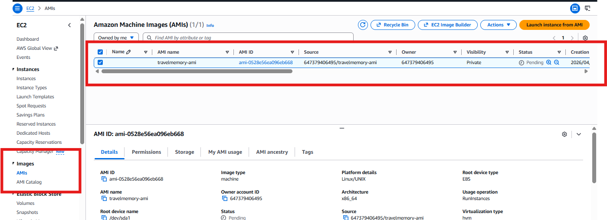

Once AMI is available , Launch the instance from AMI,
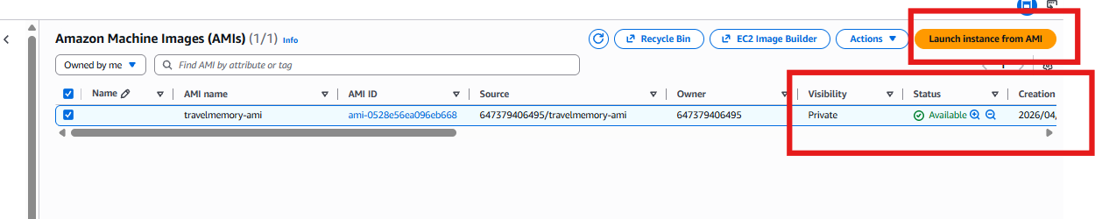
Put evertying same keystore , security poices and rules ,..etc and Instance is 2
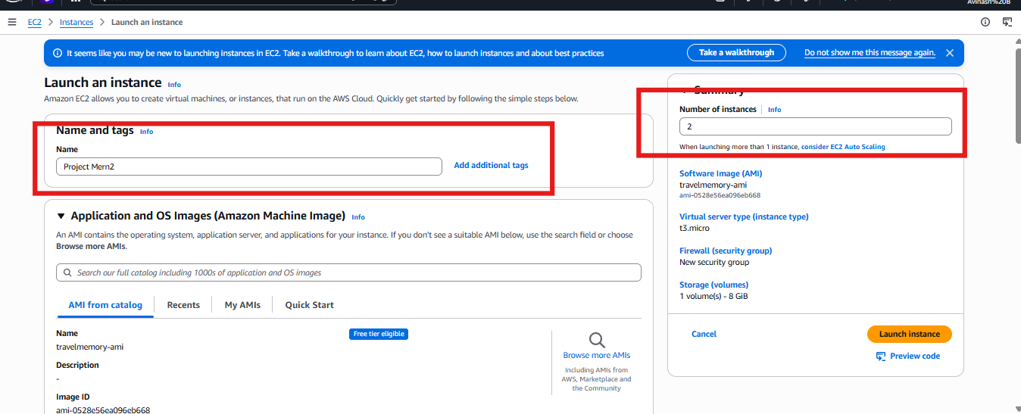
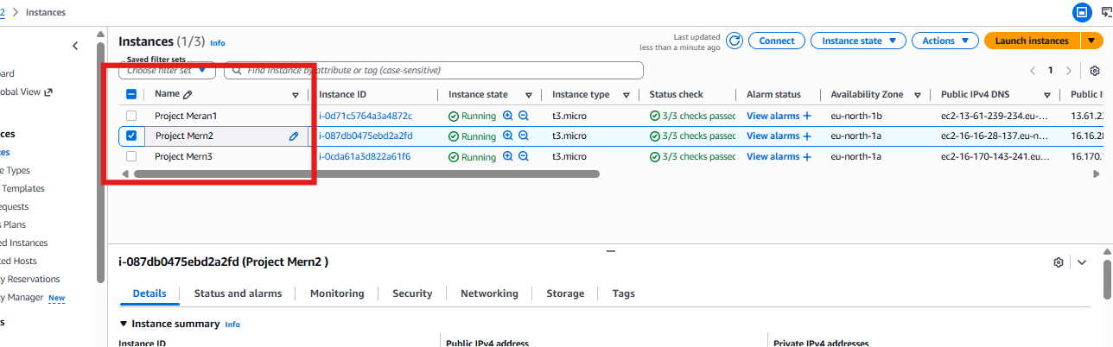

Creat Load balancer :
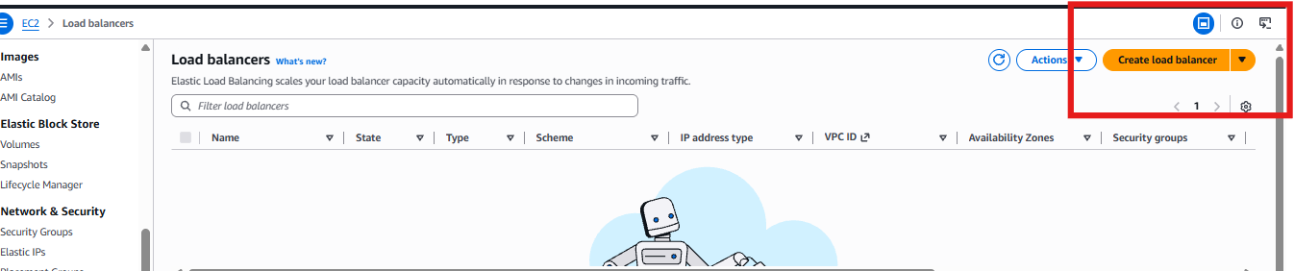
we will select Application load balancer
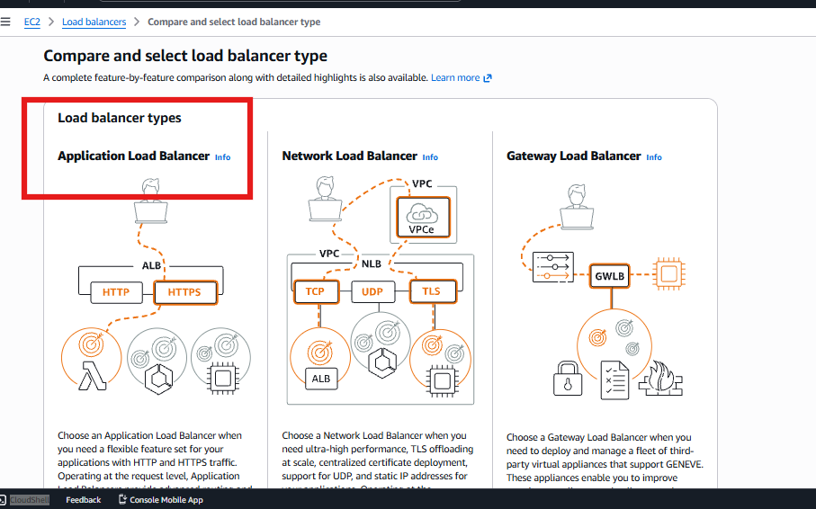
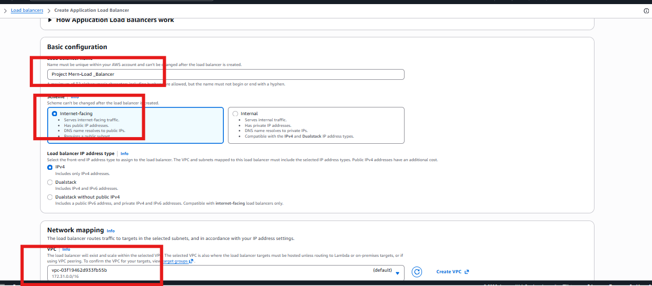

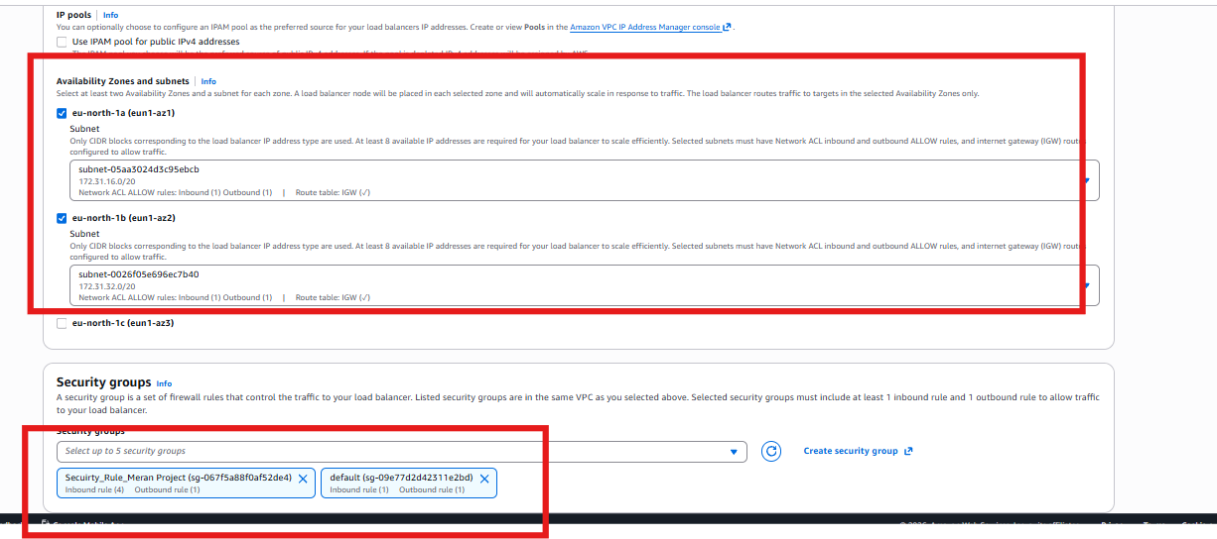
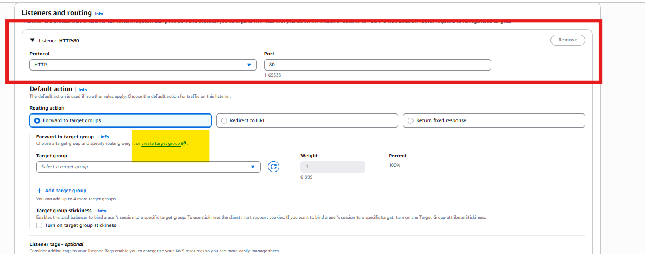

Create the Taraget group
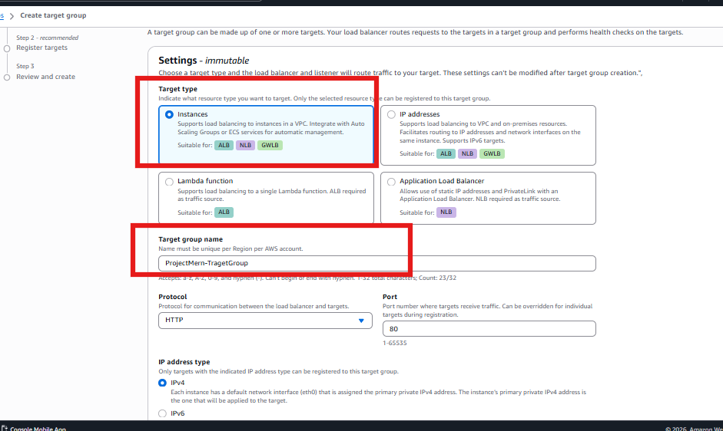
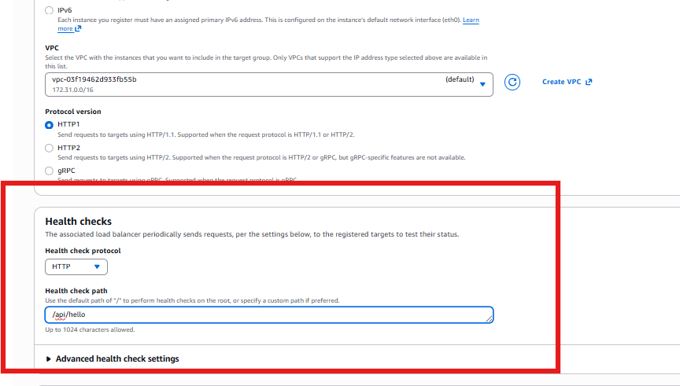
Select the three instances
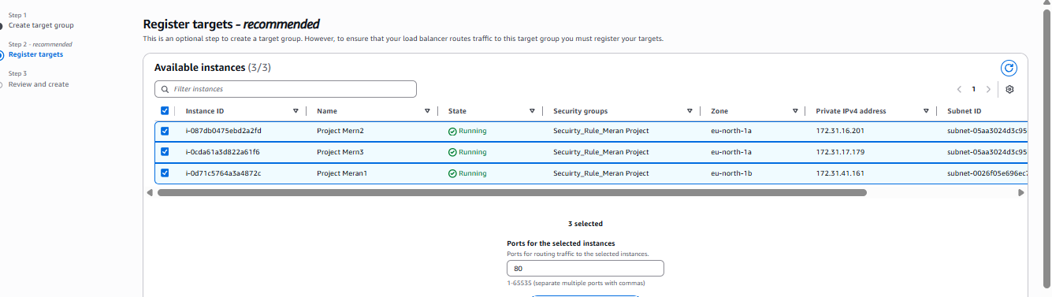
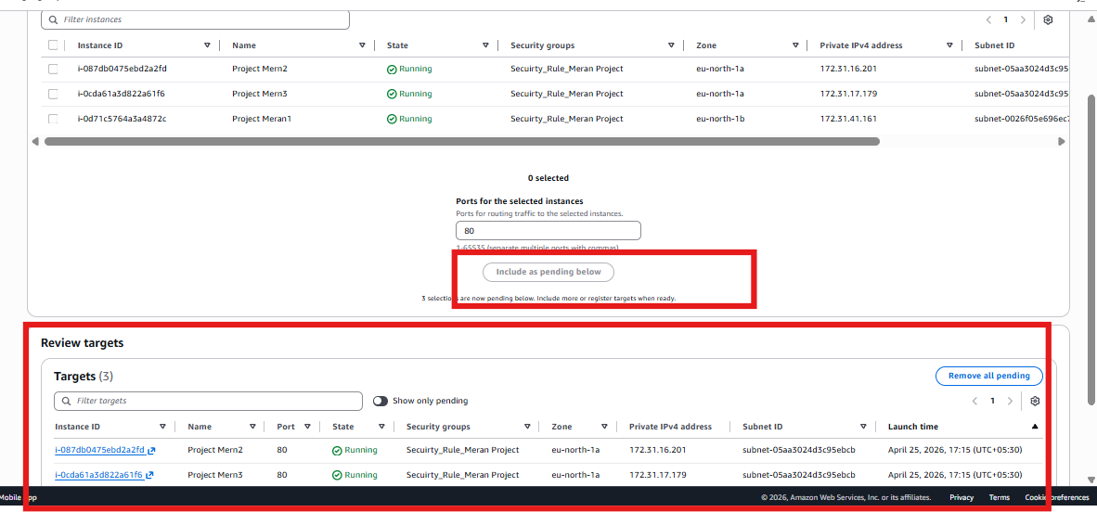
Then Creat a Traget Group and add in the Load balancer
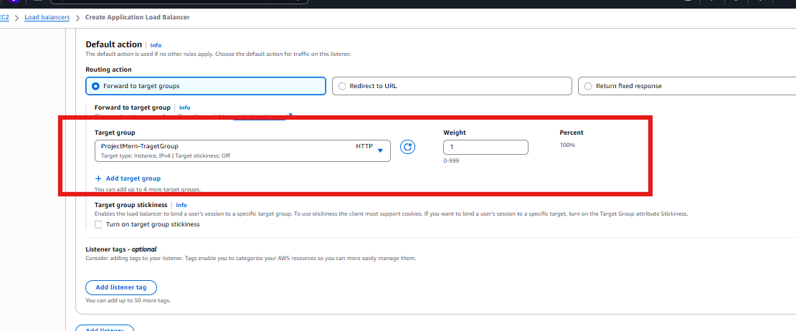

After creat , Go to the Load Balancer , It will get successful 2-5 minutes
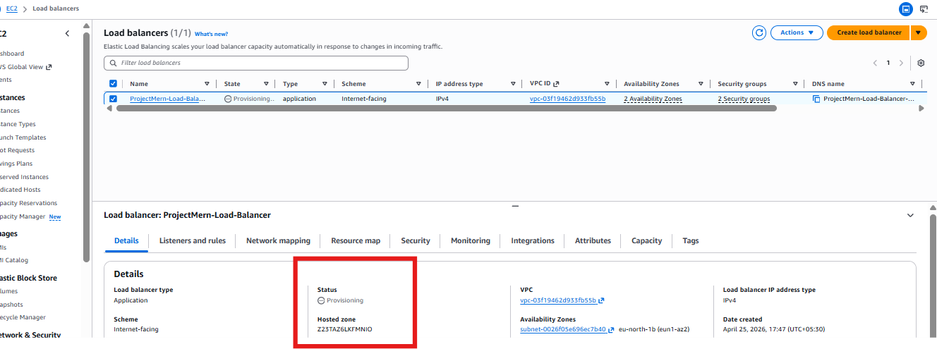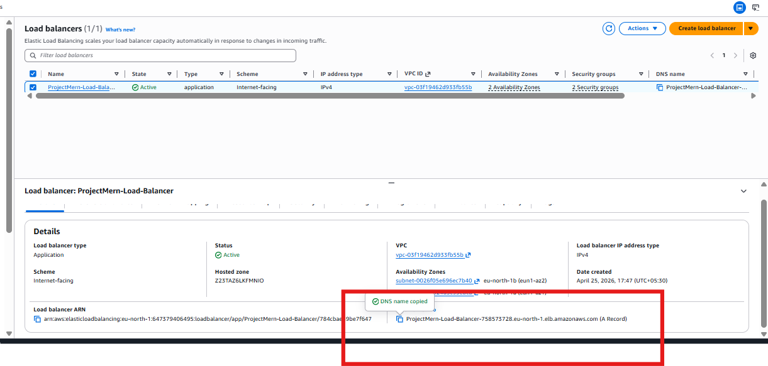Copy the DNS after it became active and check in the web

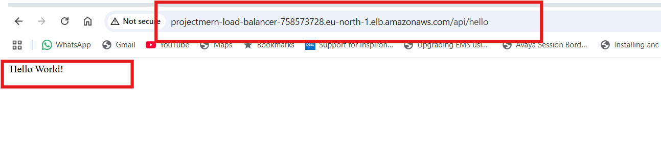

Crea a Domain and add the DNS of the domain,
Login to the Cloudflare account and add the DNS
Before that we need to creat a domain from the
godaddy or Namecheap websites
I have created the “avinashcloud.online” from the name cheap
We have to se;ect the customer DNS and add it
We have to open the Clod falr and add the Record
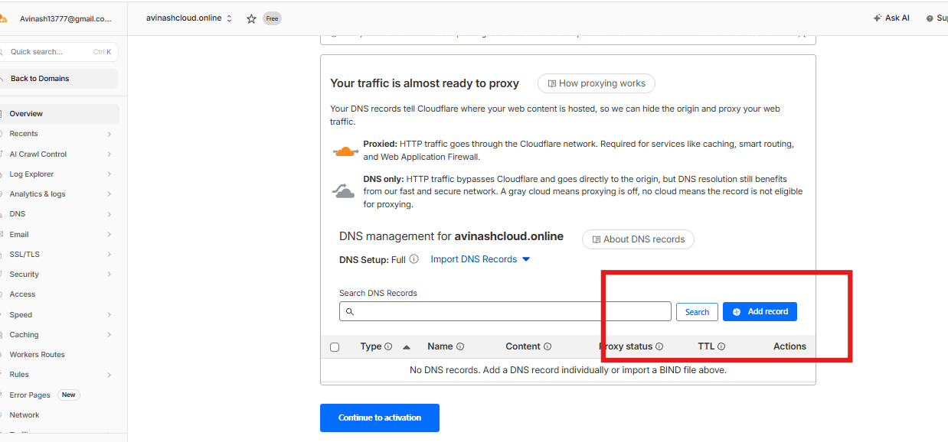
Add the www and CNAME , with the Trahet DNS os Load Balancer DBNS and do Activation
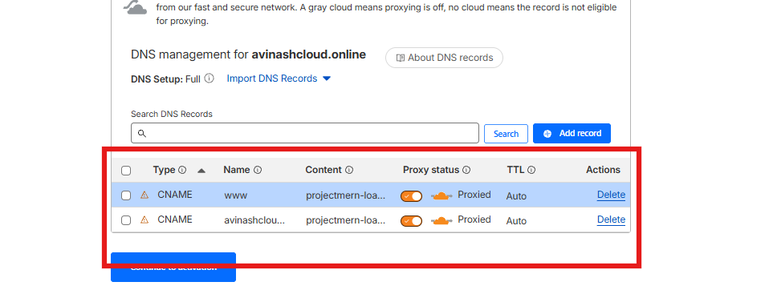
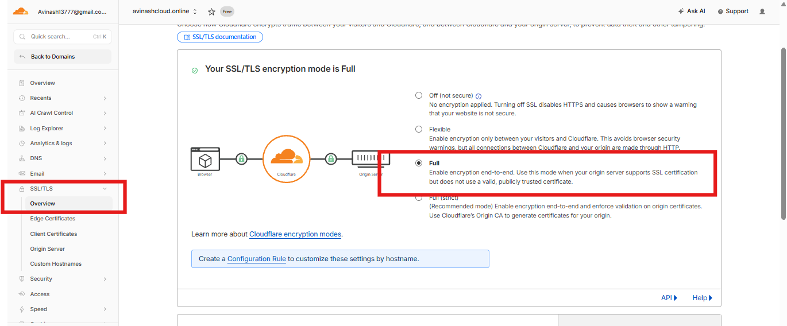
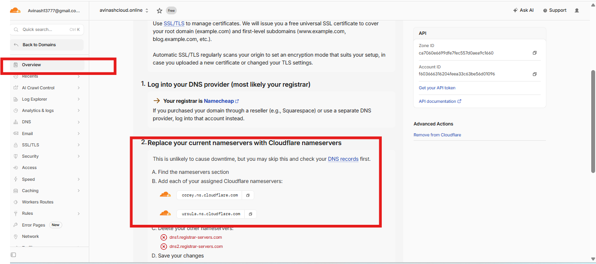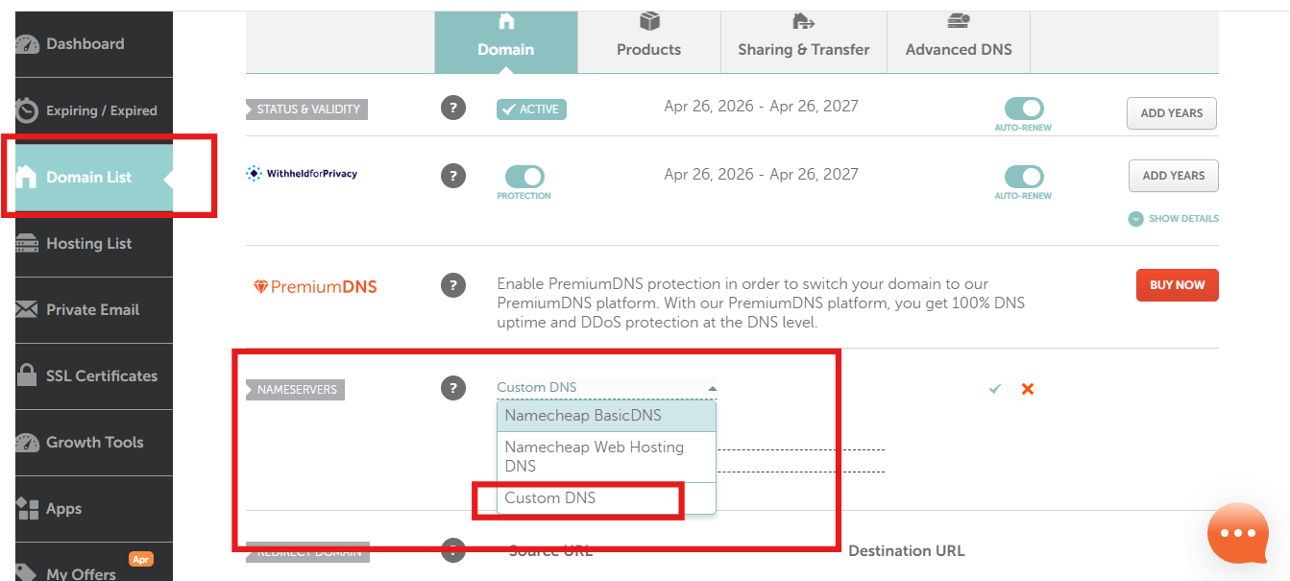
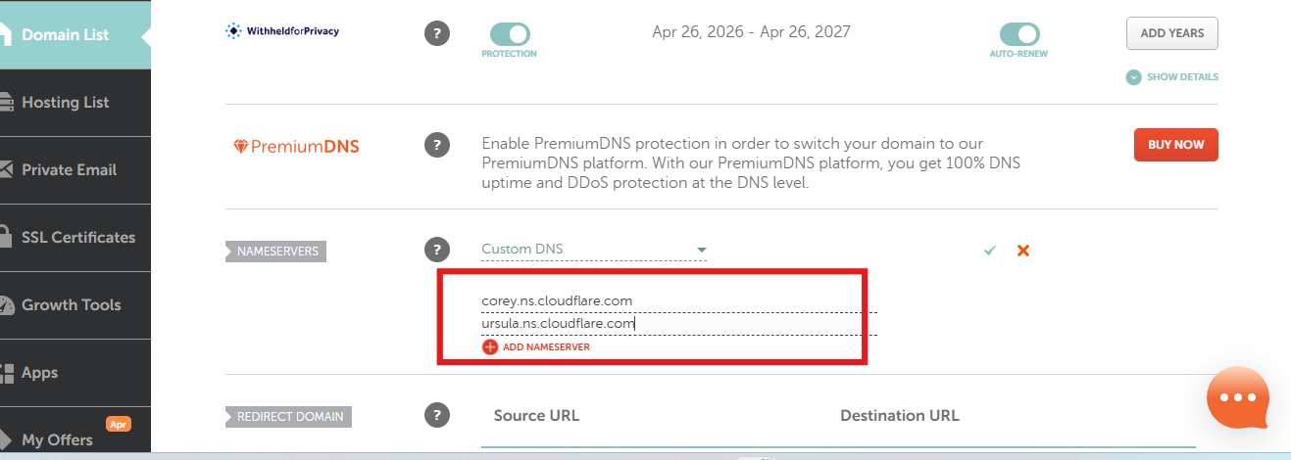

Once everting is done , wait for at leat 1 hour ,
Then check the status in clod falr,
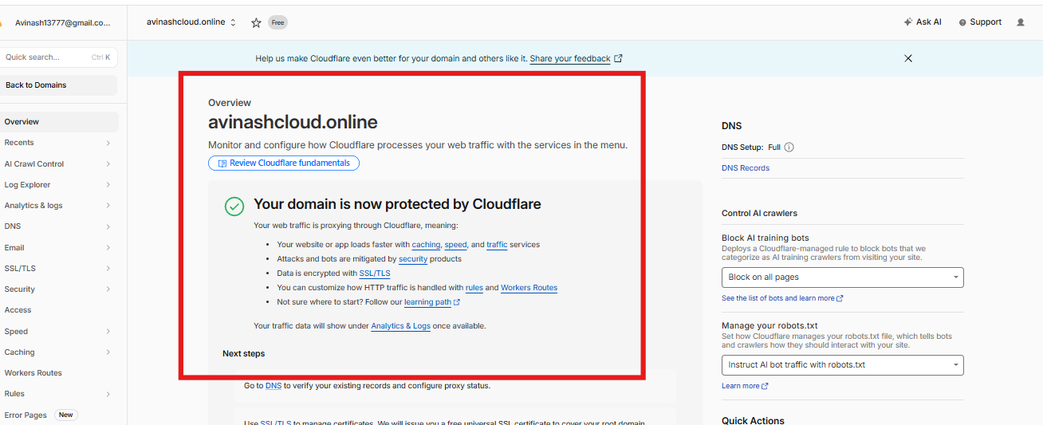
Now the web is working with the https://avinashclod.online/api/hello
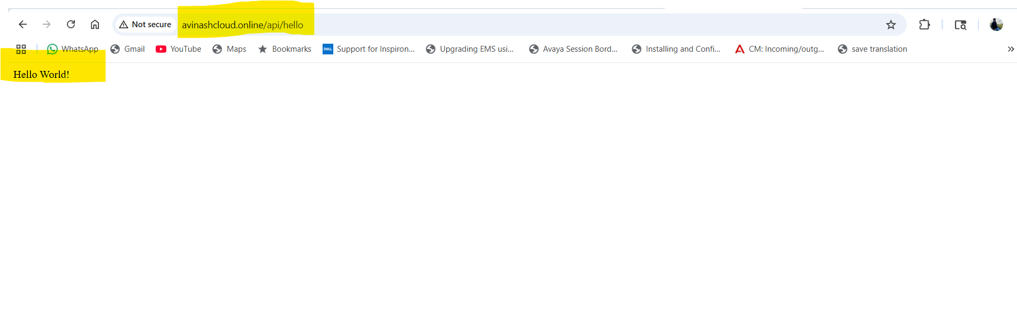

Add the URl in frount end
url.js
